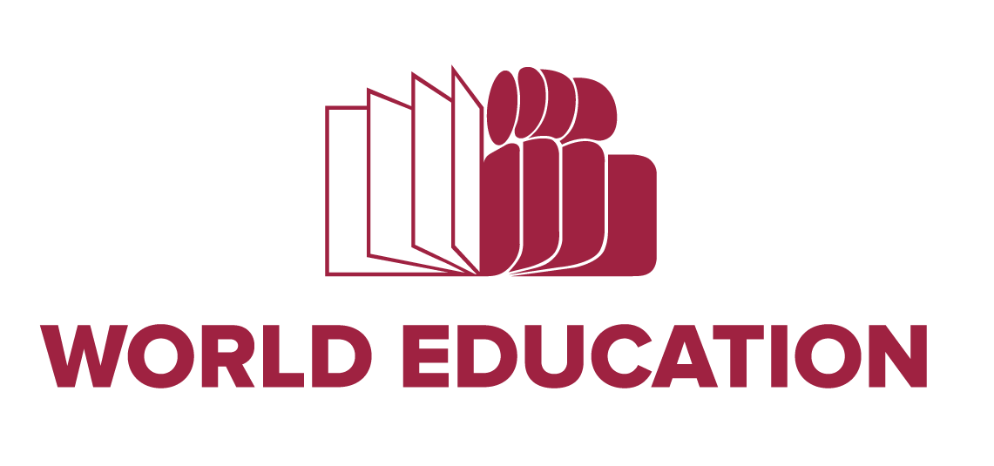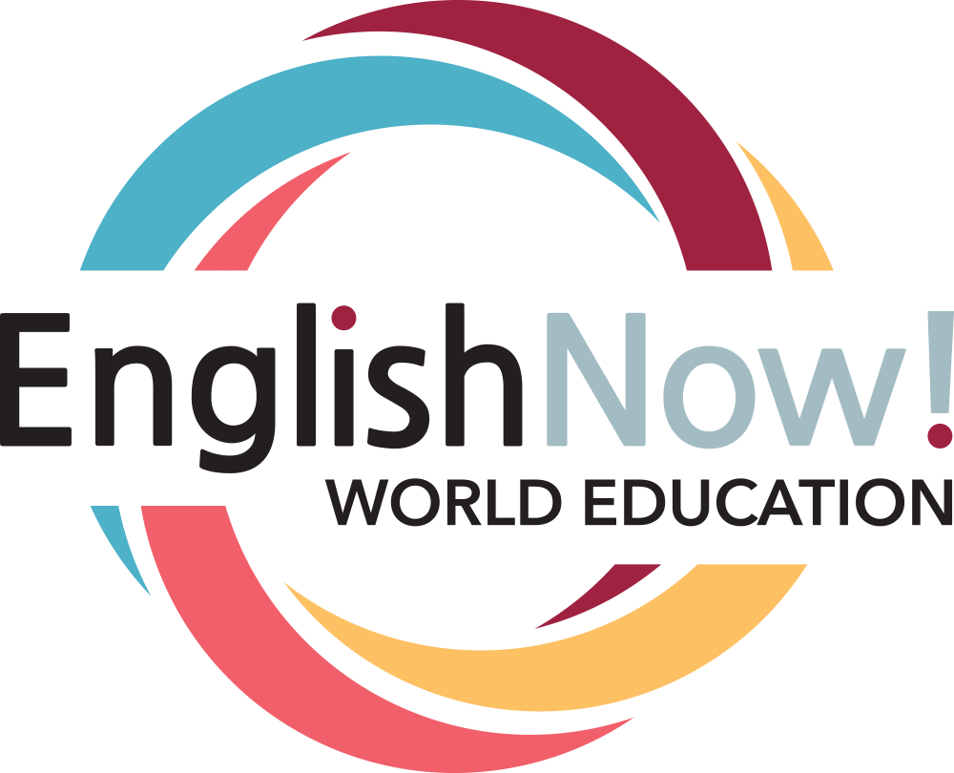

Sample Welcome Packet

Name: Date:

English Now! - Welcome Packet
Welcome to the English Now! Blended Learning Circle! We are happy to have you!
Goal: To have many opportunities/ways to support you to improve your English Skills
- Support you to get comfortable to use online program to learn English
- To give you an opportunity to share with people once a week
- Online and in-class experience, learn from one another

Class Schedule - Round 2

Date | Activities
Week 1 | Registration, Ice Breaker, CASAS pre-test
Week 2 | Welcome Packet, laptop distribution, USA Learns Introduction
Week 3 | Learning Circle
….. Week…. | Learning Circle
Last Week | Last Learning Circle, return laptops and CASAS post-test

Login Information:
Laptop
ID#
Password
USA Learns - https://www.usalearns.org/
Email address: Password: If you have questions or need help please call and ask for
or . You can also call/text at
. Notes
Sample Welcome Packet (continued)

Name: Date:

English Now! - Weekly Goal Planning and Log
(Week 1)
Today is Wednesday, .
This week I plan to spend hours studying at home.
Wednesday | Thursday | Friday | Saturday | Sunday | Monday | Tuesday

Total time=
Questions I have...

English Now! - Weekly Goal Planning and Log
(Week 2)
Today is Wednesday, .
This week I plan to spend hours studying at home.
Wednesday | Thursday | Friday | Saturday | Sunday | Monday | Tuesday

Total time=
Questions I have...

Courtesy: Carlos Rosario International Public Charter School, Washington DC

