Instructions for teachers - Print out this form; help your learners answer the questions.

Instructions for students - Please answer all of these questions. Ask for help if you need it!

*********************************************************************************************

I. Questions about technology use

1. Have you ever used a phone or a computer to learn English? If yes, name of app:

2. What kind of technology device do you have? You can select more than one.

- Smart phone
- Basic feature phone
- Tablet
- Computer
- I don’t have any

3. Do you share this device with anyone regularly? If yes, who?

4. In the past week, how have used your phone? Circle the answer. You can select more than one.

- Texting
- Voice calls
- Emails
- Messaging apps (whatsapp, viber, skype, etc..)
- Web browsing
- Apps (games, maps, etc..)

5. Do you have any problems using your phone? What?

6. Do you use the internet on your phone? Yes or No. If yes, how? Circle all of the answers.

- Mobile data plan
- Wi-Fi at work
- Wi-Fi at home
- I do not use internet on my phone.

7. (English) Do you have a cell phone plan? What type of plan? Circle the answer.

- Contract
- Pay-As-You-Go (NOT monthly unlimited)
- Pay-As-You-Go (monthly unlimited)/
- Other (contract unlimited)

7. (Spanish) Qué tipo de plan tiene? Marca la respuesta con un círculo.

- Contrato
- Pagar por uso (NO incluye llamadas ni textos ilimitados)
- Pagar por uso (incluye llamadas y textos ilimitados)
- Otro (contrato, uso ilimitado)

*********************************************************************************************

II. Using English at work.
On a scale from 1-10, how well can you do these things? Circle the number for each question.
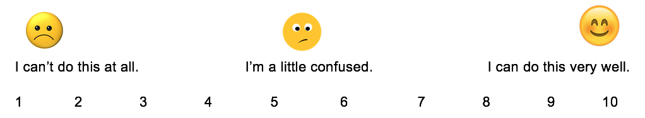

1. I can understand guests, coworkers, and supervisors when they speak to me in English.
2. I can talk to guests, coworkers, and supervisors in English.
3. I can express my thoughts and feelings in English.

On a scale from 1-10, how well can you do these things? Circle the number for each question.

4. I can talk to my supervisor in English about an issue at work.
5. I can read signs at work.
6. I can read documents and instructions at work.
7. I can read instructions on Hot SOS (on my device).
8. I can write notes to coworkers and supervisors in English.

