Log-In Reminder Card Template

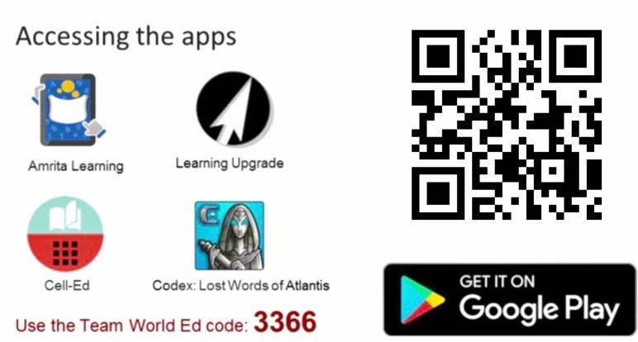
Insert image or text here. Sample in row 1 on both pages:
Insert image or text here. Sample in row 1 on both pages:

