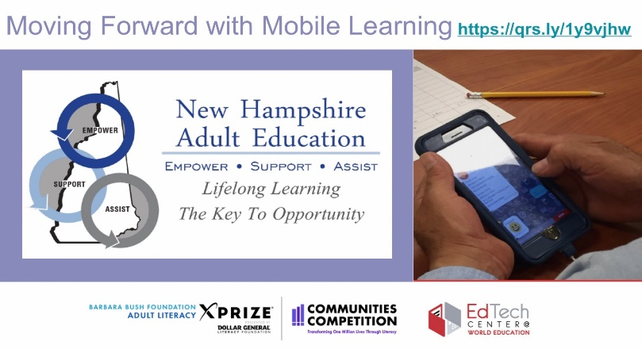 | THIS IS A SAMPLE REMINDER CARD DEVELOPED BY THE NH XPRIZE TEAM. YOU HAVE THEIR PERMISSION TO ADAPT IT FOR YOUR PURPOSES IF YOU WANT TO PROMOTE ALL 4 APPS IN ONE CARD.
