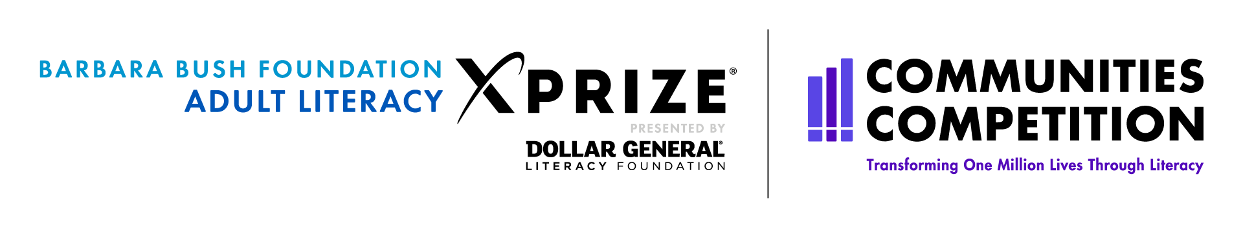  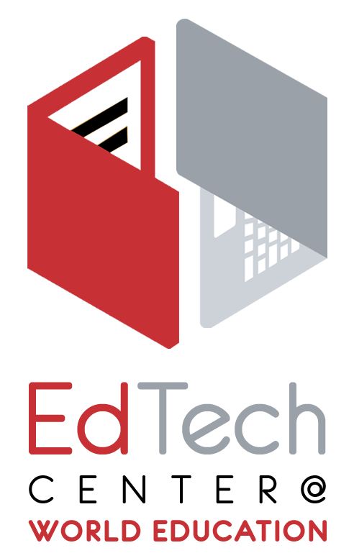  Team  WorldEd | 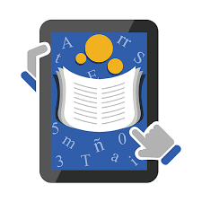  Amrita LEARNING  The Amrita Learning Reading app is especially designed for adults. Lessons start with learning letter sounds and continue to multi-page stories and articles, with vocabulary support in English and Spanish.  Specifications  Requires Android  Version 4.4 or up  Requires at least  50 MB free space  URL: https://abc.xprize.org/ac3366 | LearNing Upgrade  Students of all ages and abilities can successfully improve and master basic math, English, and reading skills with the Learning Upgrade app. The Learning Upgrade curriculum includes engaging songs, videos, games, and rewards that encourage all learners to achieve mastery. It includes more than 900 sequenced lessons. English Upgrade courses include lessons on phonics, decoding, vocabulary, grammar, writing, listening, and more.  Specifications  Requires Android  Version 4.0 or up  Requires at least  15 MB free space  URL: https://abc.xprize.org/lu3366
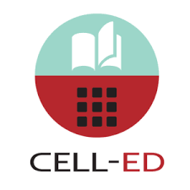  Cell-Ed  Hello from Cell-Ed! We are so glad you are here. We know you are busy and always on the go. From job to kids to daily life. So we designed Cell-Ed for you. With Cell-Ed, you can learn the skills you want anywhere, anytime. With just a click, listen to the voice of our teachers. With just a text, learn and communicate with your personal coach who can help you when you need that extra support. Complete the course and earn a certificate! It’s that easy!  Specifications  Requires Android  Version 4.4 or up  Requires at least  4 MB free space  URL: https://abc.xprize.org/ce3366 | Codex:  Lost Words OF Atlantis  Transform your literacy skills with engaging, puzzle-solving gameplay. Learn to recognize letters, build words, and read and write sentences by deciphering the ancient language of Atlantis. Play fun, timed mini-games that test your reading skills in everyday situations, from figuring out a bus schedule to paying the correct amount of cash when you go shopping. Whether you are a native English speaker looking to boost your literacy skills or a Spanish speaker learning to read English, we support you with instructions delivered in your native language.  Specifications  Requires Android  Version 5.0 or up  Requires at least  100 MB free space  URL: https://abc.xprize.org/pw3366 | How To Play  - The XPRIZE competition apps work only on phones and tablets running Android OS.  - The Adult Literacy XPRIZE Communities Competition runs April – August, 2019. The three winning teams will be announced in September. Everyone who downloads the app(s) by August 31, 2019 can use it/them for free through Aug 2020. People can get up to four apps.  - Listen to webinar recordings to gain knowledge about the 4 apps  https://edtech.worlded.org/resources/accessing-free-mobile-learning-apps-webinar/  - These apps are for ANYONE who can benefit from using them: students, their friends, family, any community residents.  STEPS:  - Go to the apps URL  - Log in using the Team WorldEd code: 3366  - Download one or more apps of your own choosing  - Use the app on at least three separate days.

