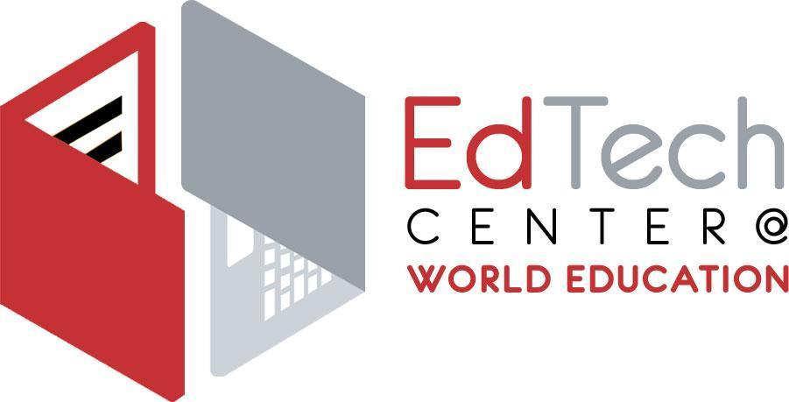
Team World Ed
Adult Literacy XPRIZE Communities Competition FAQ

What is the Adult Literacy XPRIZE?
The Adult Literacy XPRIZE was a national challenge to expand access to education for adult learners through the use of technology. Funded by the Barbara Bush and Dollar General Literacy Foundations, in the first stage of the competition, competing teams developed mobile learning apps to increase the literacy skills of adult learners. XPRIZE field-tested 8 semifinalist apps with 7,000 adults between July 2017 and October 2018. The winning developer teams were selected based on the gains made by users of those teams’ apps as measured by a pre- and post-CASAS adult literacy assessment administered one year apart. Here is a link to the February 2019 announcement of the winning teams and apps.

What is the Adult Literacy XPRIZE Communities Competition?
The Adult Literacy XPRIZE Communities Competition is a national challenge to expand access to education for adult learners through the use of technology. It is designed to “tackle the problem of adult low-literacy by putting free learning tools in the hands of those who need them the most, so learning can happen anytime, anywhere.” Competitors will compete to win a share of $1M in cash prizes by distributing free, proven-effective mobile learning apps that adults—both native speakers of English and English language learners—can use anytime, anywhere to improve their literacy skills.

There are four apps that are eligible to be used free of charge in this competition. They are designed for native English-speaking and English language learner younger and older adults at beginning-intermediate levels.

Organizations, individuals, or other entities deemed to promote hate, hateful speech, discriminatory policy, violence, or illegal activities are barred from competing in the Communities Competition.

What are these apps and where can I get them?
You can access them at these sites, but only on Android phones:

Learning Upgrade https://abc.xprize.org/lu3366
Amrita Learning https://abc.xprize.org/ac3366
Cell-Ed https://abc.xprize.org/ce3366
Codex: Lost words of Atlantis https://abc.xprize.org/pw3366

You can also access the apps at Google Play Store by searching for them, and entering the Team World Ed code: 3366 when logging in.

The XPRIZE competition apps work only on phones and tablets running Android OS. Please read the specifications on Team World Ed web pages: https://edtech.worlded.org/team-worlded-xprize/

What about iPhone users?
iPhone users can download Learning Upgrade and Cell-Ed for free from the App Store. While that does not count toward the user count in this competition, we encourage you to do that. iPhone users of Learning Upgrade will get the same content as on an Android, which is all of their lessons, including English, math, and GED/HiSET. However, only Android users will have access after the competition ends on August 31, 2019. Cell-Ed will be available on iPhone for a full year.

Who are eligible learner participants?
Eligible participants must reside in the United States and have access to a smartphone or tablet running Android OS. Competitors are not required to verify the literacy level of participants. Participants may be concurrently enrolled in adult basic or secondary education, CTE, or ESL courses but are not required or expected to do so.

What is the timeline?
The Adult Literacy XPRIZE Communities Competition runs from April 2019 – August 2019. The three winning teams will be announced in September. Everyone who downloads the app(s) on Android phones can use them free of charge through Aug 2020. Two of the four apps will be available free of charge indefinitely to people who have downloaded before the end of August 2019: Amrita Learning and Codex. Learning Upgrade and Cell-Ed will not be free after August for people who didn't already download them. You would need to contact the app developers to find out the licensing options and cost.

How do we choose which app to use?
All four apps have merit and have been field-tested with hundreds of adult learners, and have resulted in considerable learning gains as measured by CASAS pre and post-tests. They employ varied strategies in how they engage, teach, and support learners. While we do not recommend one app over another, we do recommend you keep in mind the motto "GOALS before TOOLS" and consider the instructional goals of your program and the needs of your end users before selecting the apps that you will promote and use. You are free to use them all or pick fewer, or just one, but we recommend you pick one to begin with. Each phone or tablet can download the app only once so there is no incentive to have participants double enroll.

What is Team World Ed?
Team World Ed is a growing, virtual community of adult education programs, funders, and other partners in six states: Connecticut, Massachusetts, New Hampshire, Rhode Island, Virginia, and Texas. Members include adult education programs, libraries, school districts, volunteer literacy tutoring programs, adult education professional development organizations, career centers, workplace education programs, adult education professional associations, and government and other public agencies. Team World Ed is coordinated by the EdTech Center at World Education.

Why should we join?
- Get field tested, new learning tools into the hands of adults who need them - free of charge for one entire year.
- Offer learning opportunities for students’ friends and families, and people on waiting lists. Adults do not need to be enrolled in classes.
- Speed up learning with mobile learning apps for ELLs and low-literacy native English speakers.
- Use this as an opportunity to integrate mobile learning into instruction, tutoring, and student/ client support.

What do we need to do to join?
You need to rally your staff teams to:
- Recruit adults to try one of the approved competition apps: students, their friends, family - ANYONE who can benefit from using these apps.
- Help adults download the chosen app and log in using the Team World Ed code 3366.
- Encourage adults to use the app on at least three separate days.
- Safeguard participating adult learners’ identifying information either through encryption or offline storage.

You can join Team World Ed any time; the sooner the better. Sign up HERE. Or, you can just access the apps at Google Play Store, search for them, and enter the Team World Ed code, 3366 when logging in.

Each app has its own slightly unique interface, so we encourage you to try it out yourself so that you feel comfortable helping others.

What’s the easiest way to help adults access the apps?
Based on our experience, we recommend:
- First, you should review the four apps yourself and decide which one(s) you will use and promote. Each app is quite different and uses different amounts of data.
- Give students one app at first unless they are used to downloading and using apps and really want more than one. They can always get more apps once they get the hang of it.
- Text the URL to students to help them access the app. Don’t expect people to be able to find Google Chrome, and type in the URL. Some will be able to do that, but many others will not.
- And/or help adults download the app from the Google Play Store
- Allow time in class to use the app and get peer or teacher support, if needed. Check in with learners about their experience. Where and when are you using it? What are you learning?
- Point out the app logo so they can find it on their phone.
- Download wallet reminder cards from our website and hand out to students to remind them of the app logo and how to download it from the Play Store if they were logged out or used a different phone

Can multiple students use the same device?
People can certainly use the same device – tablet or smartphone – but they will each need to use their unique login. Each app is slightly different but all require a name and phone number. Cell-Ed, for example, requires a cell phone number, and they will begin texting learners soon after log in.

What do we get if we join?
World Education will provide its Team members support in the form of:
- Customizable flyer to recruit adults in English and Spanish to download the app
- Banner for your website if you want one
- Print and video guides on how to download and log into the apps
- Monthly learning & sharing webinars

Website with these and other resources: https://edtech.worlded.org/team-worlded-xprize/

The app developers will provide standard tech and customer support to the learners using their apps.

Although the main purpose for World Education’s participation is to gain access to free learning apps for adults, there is also a cash prize! It will be awarded to the team that gets the most people to download the app and use it on at least three separate days. The three competing teams who recruit the most people to download and use these apps will win a share of $500,000. If Team WorldEd wins, funds will be distributed equitably based on level of participation. Since we are not able to track individual programs’ level of participation (number of downloads of apps), World Education will likely distribute them using a simple application process wherein the applicant organizations must demonstrate how they promoted the apps and how many adults they helped to download apps. Winners must use the Prize winnings to benefit adult learners.

Who tracks app downloads and usage?
XPRIZE will track download and usage of the apps by Team code, but they are not gathering learner data.

https://edtech.worlded.org/team-worlded-xprize

